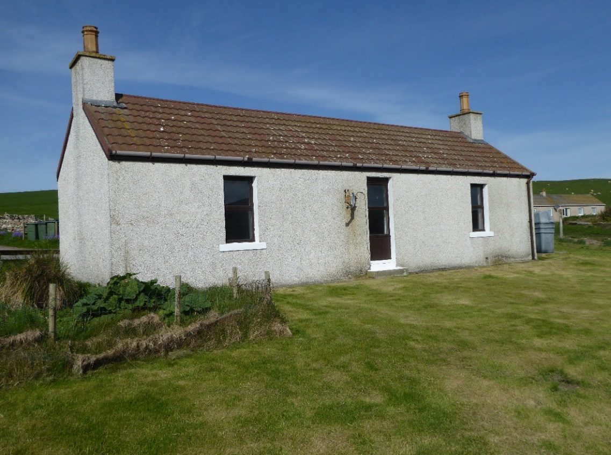

NOSS, SCOUSBURGH, ZE2 9JE

This delightful cottage and its small garden lie in the quiet and secluded hamlet of Noss in the south mainland of Shetland. Situated on the edge of farmland it offers expansive views to the east over adjoining fields and the Loch of Spiggie. The house and garden together extend to 0.685 ha (0.17 acre).

EPC RATING Band F (28)

PRICE Offers over £115,000

VIEWING Phone 07831 301503

ACCOMMODATION Porch, Living Room, Kitchen, Three Bedrooms, Shower Room and Walk-In Storage Cupboard
NOSS, SCOUSBURGH, ZE2 9JE

This property was originally a “But & Ben” cottage built over 100 years ago, which has since been extended. It is situated in a very peaceful rural location within approx. 22 miles of Lerwick. It is double glazed throughout with Adamsons windows and benefits from oil-fired central heating.

The local amenities are grouped together at Dunrossness (about 3 miles from the house), on the main Lerwick to Sumburgh road. These include a mini-supermarket with post office & fuel, and the area's primary school. The house is also handily placed for the airport at Sumburgh (6 miles approx.), for air travel to mainland Scotland. Local attractions include the archaeological sites at Jarlshof and Old Scatness Broch, Sumburgh Head Lighthouse and Nature Reserve and the beaches at St Ninian’s, Scousburgh and Quendale.

Council Tax is understood currently to be Band A. Prospective purchasers should however contact Shetland Islands Council directly for confirmation. Details of Council Tax rates can be found on Shetland Island Council’s website at:
http://www.shetland.gov.uk/counciltax/charges.asp

Accommodation comprises:

PORCH - (Approx. 1.6m x 1.7m)
The half glazed front door leads into the Porch with v-lined pine walls, carpet and double socket. An inner half glazed natural timber door leads to the interior passage-way (measuring approx. 7.5m x 0.75m) which has a storage cupboard with double louvre doors, a radiator and smoke alarm. This in turn provides access to the various rooms.

KITCHEN - (Approx. 3.5m x 2.6m)
The kitchen features fitted units with timber doors and work surfaces over, matching wall mounted units, an inset single drainer stainless steel sink, a Beko fridge freezer, double oven with ceramic hob and a Bosch washing machine, vinyl flooring, a larder cupboard with louvre doors, double radiator, three double sockets and a wired in heat alarm.

SHOWER ROOM - (Approx. 2.25m x 1.62m)
Next to the kitchen is the Shower Room, with wash hand basin, toilet and a wet-wall lined curved corner shower cabinet. The floor is carpeted. Other features include a bathroom cabinet and a double radiator.

BEDROOM 1 - (Approx. 4.1m x 3.7m)
Opposite the Shower Room is Bedroom 1, with a window offering views towards Spiggie Loch. With carpet, double panel radiator, painted v-lined ceiling, two double sockets and one single socket. The two double wardrobes are included in the sale.
LIVING ROOM - (Approx. 4.12m x 4.1m)
The Living Room again has an easterly aspect, with painted v-lined walls. Other features include a natural timber hearth and mantle unit with electric fire, a storage cupboard with double louvre doors containing the hydro meter and MCB units, an interlinked smoke alarm and carbon monoxide alarm, two double sockets and a hatchway to the Loft. The glass fronted display/ storage unit with drawers beneath and the corner unit are included in the sale.

BEDROOM 2 - (Approx. 4.15 x 4.3m)
Known as the “But & Ben Room” and being part of the original house, this could easily be converted into a spacious bedroom. The window offers views towards the east and Spiggie Loch. The walls and ceiling have painted timber v-lining. The old fireplace has been blocked up. Features include a double radiator, vinyl flooring, two single sockets and one double and a Velux roof light. The large dresser is included in the sale.

WALK-IN STORAGE - (Approx. 0.87m x 0.61m)
A door leads off the end of the Passage to a small area lined with 6 cupboards providing shelved storage space.

BEDROOM 3 - (Approx. 4.0m x 2.7m)
This carpeted room has a bright southerly aspect. Features include a central pendant light feature, timber hearth/mantle unit with electric fire, recessed shelving and cupboard beneath with double louvre doors, telephone socket, two double sockets and double radiator.

GARDEN
The garden comprises a grass lawn to the east and a drying green to the north with a small flower bed. The south and east boundaries are bounded by a timber rail fence A small vegetable plot is located at the south end.

